TERMS OF REFERENCE

Service Specifications

THE SOFTWARE FOR BUDGET, FINANCE, REVENUE AND NON-FINANCIAL ASSETS MANAGEMENT INFORMATION SYSTEM (BFRAMIS) AND HUMAN RESOURCES MANAGEMENT INFORMATION SYSTEM (HRMIS) FOR KOSOVO JUDICIAL COUNCIL (KJC)

Table of Contents
I. GENERAL REQUIREMENTS 3
1. INTRODUCTION 4
2. PURPOSE AND OBJECTIVE 4
3. GENERAL DESCRIPTION 5
II. SERVICE REQUIREMENTS 6
4. SERVICE SPECIFICATIONS 6
5. SOFTWARE SYSTEM NEEDS 7
6. PROCESS FLOW OF BUDGET AND FINANCE PAPERWORK 8
6.1 Perspective of the Budget and Finance software module 9
6.2 Description of Budget and Finance software system 10
6.3 Budget and Finance requirements 13
7. CONCEPT OF HUMAN RESOURCES MANAGEMENT, DOCUMENT REPOSITORY AND ADMINISTRATIVE SERVICE 21
7.1 Document Repository 22
7.2 Common Workspace 24
7.3 Perspective of HRMIS software module 27
8. SOFTWARE FUNCTIONAL REQUIREMENTS 32
9. SPECIFIC REQUIREMENTS 33
10. CORE SERVICES 36
10.1 Web Application Development 36
10.2 Web Application Hosting 37
10.3 Maintenance & editing of the Web - Application 37
10.4 Security and Technology 38
10.5 Application Audit 38
11. PROJECT PHASES 39
12. PROJECT REQUIREMENTS 39
13. NON-FUNCTIONAL REQUIREMENTS 41
14. TRAINING REQUIREMENTS 41
15. SUPPORT AND MAINTENANCE 42
16. PROJECT TIMELINE 43
17. PROJECT COST REQUIREMENTS 44
18. RESPONSIBILITIES OF THE PARTIES 45
III. LIST OF ACRONYMS/ABBREVIATIONS 46

Figure 1. Payment procedure for order and purchase invoice 9
Figure 2. General use case diagram for BFRAMIS 10
Figure 3. Offical’s Use Case diagram 12
Figure 4. Administrator’s Use Case diagram 12
Figure 5. HR Management Information System 21
Figure 6. Common usage Use Case diagram for HRMIS 27
Figure 7. Authorisation/Authentication 28
Figure 8. Manager’s Use Case diagram 28
Figure 9. HR official’s Use Case diagram 29
Figure 10 Administrator’s Use Case diagram 29
Figure 11. Possible features of the BFRAMIS software module 34
Figure 12. Possible HRMIS database architecture 35

Table 1. Support and maintenance requirements 42
Table 2. Service Level Agreement - SLA 42
Table 3. Project time chart 43
Table 4. Cost requirements 44

GENERAL REQUIREMENTS
MANAGEMENT OF SOFTWARE REQUIREMENTS FOR ORGANIZATION OF THE DEVELOPMENT AND IMPLEMENTATION OF BUDGET, FINANCE, REVENUE AND NON-FINANCIAL ASSETS (BFRA), AND OF HUMAN RESOURCES (HR).

INTRODUCTION
The Budget, Finance, Revenue and Non-Financial Assets Management Information System (BFRAMIS) and the Human Resources Management Information System (HRMIS) is an IT software application system for the Kosovo Judicial Council (hereinafter referred to as KJC) and for the Courts. The purpose of this action is to support the relevant staff responsible for managing the budget, finances, non-financial assets and human resources in their daily work using the computer program. Moreover, the system is required to be developed and implemented, as well as the users to be trained and support the maintenance of the software system.
In addition, the development process requires project and team management as well as reporting and managing the expectations of the system end-users (staff).

PURPOSE AND OBJECTIVE
The objective is to contract a company with experience in software development (a firm or company, hereinafter referred to as contractor) in order to provide the software development and implementation for BFRAMIS and HRMIS.

- Budget, Finance, Revenue and Non-Financial Assets Management Information System (BFRAMIS)
Through this project, KJC aims to increase efficiency and transparency in the field of finance, starting from budget planning, allocation of funds, commitments, expenditures, financial reporting, revenues and deposits as well as non-financial assets (capital and non-capital assets).
With this software system, KJC intends to create an advanced system that will digitalize the work process currently carried out in KJC using MS Excel and manual records, but also some of the partly digital records. According to the Law on Public Finance Management, the budget organizations are obliged to maintain accounting records in KFMIS (Kosovo Financial Management Information System), Treasury system, and accounting records of the budget organisation and to match the data between these systems. The aim is to implement automatically (if applicable) these links between two systems for data matching. Moreover, this system aims to provide the technical possibility of linking with e-Pasuria system for asset management by the Ministry of Interior Affairs – MIA (if there is an agreement in place between institutions for asset management).
The new system must also enable the interlink (data exchange through API) with the CMIS (Case Management Information System) internal system in certain areas where KJC requires, in order to define what data to exchange during the development phase.
The new system should also be able to connect to other existing systems, (e.g., through API) in the future, such as: Civil Registry, Business Registry, Address Register.

- Human Resources Management Information System (HRMIS)
Through this project, KJC aims to integrate the HR MANAGEMENT INFORMATION SYSTEM in its entirety:
- To provide a digital solution that will help to automate HR/Administration functions and processes.
- To provide a solution that helps to comply with the HR standards, statutory requirements and best practices and implement their strategic management.
The provision of both software modules and implementation services will be the responsibility of the successful bidder, subject to the satisfactory performance of the service provider, during and after a competitive bidding process.

GENERAL DESCRIPTION
Terminology (based on RFC2119 document)
The key words "MUST", "MUST NOT", "REQUIRED", "SHALL", "SHALL NOT", "SHOULD", "SHOULD NOT", "RECOMMENDED”, “MAY", and "OPTIONAL" in this document are to be interpreted as below:

MUST – This word, or the term “REQUIRED” or “SHALL”, mean that the definition is an absolute requirement of the specification, thus an obligatory criterion.
MUST NOT - This phrase, or the phrase "SHALL NOT", mean that the definition is an absolute prohibition of the specification.
SHOULD - This word, or the adjective "RECOMMENDED", mean that there may exist valid reasons in particular circumstances to ignore a particular item, but the full implications must be understood and carefully weighed before choosing a different course.

SHOULD NOT - This phrase, or the phrase "NOT RECOMMENDED" mean that there may exist valid reasons in particular circumstances when the particular behavior is acceptable or even useful, but the full implications should be understood and the case carefully weighed.

MAY - This word, or the adjective "OPTIONAL", mean that an item is truly optional.

SERVICE REQUIREMENTS

SERVICE SPECIFICATIONS
This is a technical service that MUST be tailored to the needs of KJC, enabling optimization of IT operations, the maximum benefit from the software management system and the latest technology solutions. With this service, KJC should benefit from information (data) management, technical advice and training. The coordination of activities is the responsibility of the Contractor (e.g., Project Manager – as a single point of contact), who knows and understands the needs of the KJC and their IT system environment.
The solution MUST be fully developed as tailor-made EXCLUDING any customized/ready-to-use platform/solution.
It is expected that the End/Common Users (Finance and Budget Officers and HR Officers of the KJC and relevant Courts according to horizontal and vertical organization – reference organization of the entire court system) shall be trained to use the new system on daily basis as well as providing the training for special users/administrators. The details of training are set out in Section 14 (Training Requirements).
It is expected that the development and implementation of system, including training, MUST take no longer than six (6) months (from the date of Contract singing to the date of Final Acceptance), for more please refer to Section 16 (Project Timeline) and 12 months of system maintenance (starting after the Final Acceptance) as specified in Section 15 (Support and Maintenance).
The contractor MUST submit the schedule of all its activities in a project: for constructing the solution, including the 12-month service of maintenance and support.

SOFTWARE SYSTEM NEEDS
The KJC lacks an internal liaison system between responsible officials within the Department of Budget and Finance and other officials. Such a system will show when the commitment was made, when the expenditure was made and when the payment was certified, if there are delays in payments, etc. Currently, each official within the Budget and Finance Department has a simple MS Excel program for their needs, which shows the activities performed, however there is no direct supervision from the Head of the Budget and Finance Department during the payment process. Therefore, in order to increase the effectiveness of the Institution's Budget and Financial system, there is a need to develop a platform/database that would manage the entire financial process, starting from the commitment to the certification of payments and its finalization, including the management of their revenue and management of non-financial assets. This platform/database can incorporate all institution’s staff, who are involved in budget planning and execution of the budget and payments, by ensuring access for all responsible staff participating in the execution of payments as provided by the applicable legislation. The proposed platform/database should also include donations granted to the Institution. The platform/database should have special software which will connect all relevant officials.
Furthermore, the situation is nearly the same with the HR/Administration Department or Division, where the HR Officer (s) create (maintain) a simple MS Excel program for their needs and update it manually when required. There are no links (interlinks) among the data for employees, occupations, salaries and employee wages within the MS Excel file. Therefore, in order to increase the effectiveness and efficiency of the HR system, it is also necessary to develop a platform/database that will manage the entire HR process.

PROCESS FLOW OF BUDGET AND FINANCE PAPERWORK
The existing workflow includes (but may not be limited to) five distinct phases that must be completed while the New Purchase Order is approved for execution. A very similar process is followed for accepting payments (invoices). The following diagram represents the flow process:
Figure 1. Payment procedure for order and purchase invoice

Currently, the process participants use their own MS Excel spreadsheets to keep records of their activities. This leads to problems in monitoring workflow documents and meeting payment deadlines (invoices). Therefore, it is recommended to automate these processes using the simple workflow solution that shall be developed and implemented.

Perspective of the Budget and Finance software module
The Budget and Finance Management Information System is an internal online system to be operated on the intranet used by at least six (6) types of KJC employees. These types have different roles and can be for example: Official 1, Official 2, Official 3, Official 4, Official 5 (the names will be changed as a decision of the KJC before the software is codified) and Admin (Administrator). Each user enters the main authentication page and after that the system grants them authorization. Once the users are authorized according to their rights (roles), they basically search and edit the database through the budget, finance, revenue and non-financial assets management information system.
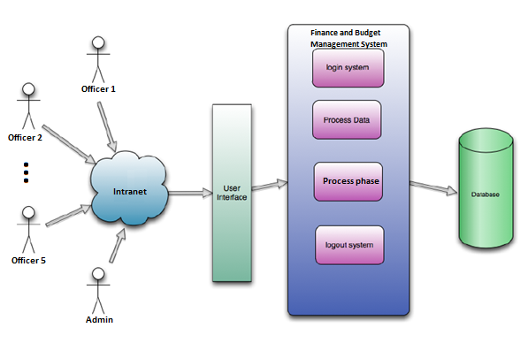
Figure 2. General use case diagram for BFRAMIS

Description of Budget and Finance software system
Budget and financial processes go through different phases and are approved by different responsible officials. In this regard, the budget and financial system is divided into two levels:
- Budget planning and execution,
- Budget management (including revenue and non-financial assets management)
The current situation involves different officials of at least 5 types (due to different stages), starting from initiation, approval, acceptance, expenditure, up to certification. Further detailed requirements are explained in Sub-Section 6.3 (Budget and Finance Requirements). Each of the responsible officials is therefore dependent on one another in order to further advance the execution process
On the other hand, the budget management process depends on the Manager of Department or Head of Division who is responsible for recording and updating all the information required for KJC. The manager of department/head of division foresees to delegate this responsibility from time to time in his/her absence.
The management software must digitize all budget and finance processes for all phases at two levels (which are based on the Law on Public Financial Management and Accountability, amendments to this Law, as well as secondary legislation in force).
In the first phase, the officer should be able to initiate the process and after its completion, the officer responsible for the next phase should be able to notify that the status of the process is awaiting his/her responsibility of continuation. In relation to this, all the stages should go up to the certification. The Administrator or Department Manager/Division Head should be able to see the status of the process at any time by logging into the software. Each official should be automatically tracked for his/her changes (logs).
Each responsible employee will be added to the system through the employee's job ID.
Upon the addition, each official is granted the right to enter the system by admin (administrator). In this stage, admin defines the user type role and this user is given a password.
In the login state of the system, each user sees the same interface seeking for a user, using their associated username and password. After logging into the system, each user sees different user interfaces depending on their role and access (e.g., Official 1, Official 2, Official 3...Admin, etc. This depends on the roles and responsibilities of the division/department or other sectoral divisions). In this stage:
    - Official 1 (initiation phase) should:
- Record requests for process initiators, e.g., tendering procedures or similar:
- Search data that fall under his/her responsibility or search all recordings of any user he/she wishes, if prior approval is given from his/her manager:
- Modify the records under his/her responsibility:
- Receive information report related to the status of data (process) he/she wants to learn.
    - Official 2/3/4/5 (depends on stages) should:
- Make approval/acceptance/commitment/certification accordingly;
- Search data that fall under his/her responsibility or search all recordings of any user he/she wishes, if prior approval is given from his/her manager:
- View and modify their data;
- Receive information report related to the status of data (process) he/she wants to learn.
    - Admin should:
- Edit data of any user (e.g., Official 1/2/3/4/5, etc)
- Add users, in other words creates a valid account to access the system;
- Edit role properties/rights, for example the need may occur to change attributes of any role type for each user. In this kind of situation may be necessary to change properties of any type and role;
- Add a new type of role to the system;
- Search for users who have specified desired skills or properties.

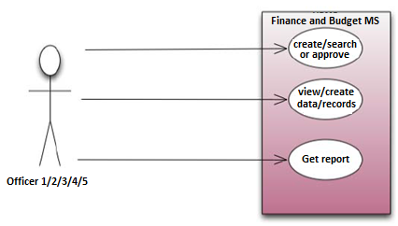
Figure 3. Offical’s Use Case diagram

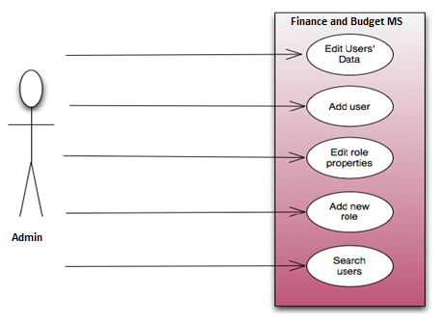
Figure 4. Administrator’s Use Case diagram

Budget and Finance requirements
The entire digitalization of the work process of the Budget and Finance Department of the KJC as well as the divisions in the relevant Courts is planned (according to the same total budget plan) through this system, starting from (but not limited to):

6.3.1 Budget planning and execution
a. Budget planning management;
b. Allocation management;
c. Commitment management;
d. Expenditure management;
e. Case certification management;
f. Management of cases with “pending” status;
g. Procurement and contract management;
h. Document management;

a. Budget planning management
The system must allow the recording of all budget data from programs, economic categories, as well as funds (origin of funds), starting with the original budget, changes occurring with budget review, changes according to savings and government decisions (always keeping the original version of the budget), etc. Creating the possibility of distributing funds by economic codes and subcodes and as a total.
b. Allocation management
The system must allow for allocations to be recorded on a time basis, i.e., monthly and quarterly, based on categories and programmes.
In the category of wages and salaries, the allocation should be made on monthly basis (the data must be provided after the wage control by the HR of the SKJC submitted to the Ministry of Public Administration – MPA). Moreover, the possibility of correction and retroactive payments should be ensured.
In the category of goods and services and public utilities, the allocation of funds should be made on monthly and quarterly basis. In these two categories should be added the planning of expenses on a monthly basis and the ability to see the balance of unexpended funds each month.
In the category of capital investments, the allocation should be made on monthly basis according to the number of capital investment projects.
In the allocation component, the possibility of corrections and changes should be provided based on the budget review. The system should provide with the possibility to have monthly and quarterly allocation balance through report.
Financial officers from the regions (lawyer, expert, translator, laymen, etc. according to the relevant code), after receiving the invoice, must register in the system, the minimum of the following data:
- Invoice date
- Invoice number
- Personal number
- Business number
- Fiscal number
- Bank account number
- Name and surname
- The month for which the commitment or payment is dedicated
The system should limit the invoice for lawyers to an appropriately determined amount (KJC will confirm the amount in the first phase or during the development of the system software) and not exceed the amount for the same lawyer.
Furthermore, if the Courts’ Financial Officer notices that he/she is a new supplier, then the supplier’s form must be attached to the system and filled in with the data required in the form. The required documentation must be attached and sent electronically to the budget and finance allocation at the Secretariat.
The system shall also have the payments for the categories specified above in order to check that the amounts are accurate.

c. Commitment management
The system should make it possible to register all commitments according to economic categories and programs from the requesting units. This excludes the commitment for the salary and allowances category.
Some data to be recorded when making funds:
- Recognition of the invoice date (protocol - automatic)
- Commitment date
- Reference number
- Fund sources
- Program code
- Economic code
- Project code
- Description
- The commitment number generated by the system (this system, as the protocol number of the KJC or as their proposal - must be determined during the request analysis phase), etc.
If an eventual error occurs during the commitment, an opportunity for correction should be provided. The system shall enable the reports drafting for each commitment and generation of the current balance for the remaining funds.
The system should also allow for the inclusion of the procedure without procurement, where a request for manager approval is made during the commitment process. Once approved, it goes to the Expenditure Officer's part and notifies the appropriate officer to proceed with the (pending) case through the expenditure process. The system must allow the attachment (uploading) of relevant documents during this procedure, too.

d. Expenditure management
The system should enable the recording of all expenses (data linked from the commitment component).
Expenditure component should at a minimum include:
- Payment date
- Beneficiary
- Invoice number
- If the payment is made in instalments, then the opportunity to record the instalment must be given
- If the expenditure is in the procurement component, the opportunity should be given to conclude the contract and to choose which contract the expenditure is for. This will allow the responsible officials of the institution to know at any time how much money is left from the contract.
- Remarks - the possibility to write any remark, comment, etc.
Small payments in petty cash and payments in advance in courts and KJC shall also be provided as a part of solution and included in the software. Moreover, the system should enable to generate reports for each daily, weekly, monthly and quarterly expenditure, as well as to accept detailed notification for the case that is pending awaiting expenditure.

e. Case certification management
The certification component should only enable payment approval (other details are complete). The system should allow for the scanned invoice and form after certification to be archived, in order to have assurance of payment, so that at any time we have the payment by invoice.
Moreover, the system should enable to generate reports for each daily, weekly, monthly and quarterly certification, as well as to accept detailed notification for the case that is pending awaiting certification.

f. Management of cases with “pending” status;
Pending cases are cases with errors that have been entered into the system but have not been processed for payment due to an error. The system should allow for the case to be sent back to the relevant officer for further completion/correction.

g. Procurement and contract management
To implement and monitor expenditures for concluded contracts through procurement, in order to include contracts with key data, such as:
- Contract name
- Contract number
- Deadlines
- Contract value
- Purchase Order placement
- Actual budget after each payment expenditure, using the budget for the specified contract.

The system must allow the attachment (upload) of each contract, so that during the commitment, (approval by the manager), expenditure and certification, we have the attachment so that the payment can be verified faster and safely when in the procedure.

h. Document management
The attachment of scanned financial documents should be part of this database as financial matters are archived knowing that there are many requests for access to multiple subjects, and not just for the previous year. Verification through scanned materials is easy and in this case the possibility of accessing physical copies is avoided.
Financial case should namely include the following documents
- Commitment request
- Commitment (CPO)
- Purchase order
- Goods invoice
- Expenditure
- Contract
- Other supporting documents

6.3.2 Budget and asset management
a. Invoice management, barcode generation
b. Donation managements;
c. Non-financial assets (warehouse) management;
d. Accounting management;
f. Asset depreciation;
g. Document management;
h. Court revenue and deposit management

a. Invoice management
The system must enable recording of all invoice data, such as: invoice number, invoice date, economic operator, invoice items, prices of items on the invoice, their location, receiving commission registration, type of assets by economic code, purchase order number, and generation of unique code - barcode for each item registered in the system.

b. Donation management
The system must enable the registration of donation data, such as: invoice number (or donation protocol number in the absence of an invoice number), invoice (or protocol) date, donor registration, item/goods invoices, prices of the items on the invoice (or from the estimation report), location of items, receiving commission registration, the type of assets by economic code and generation of a unique code for each item registered in the system.

c. Non-financial asset (warehouse) management
The system must enable the management of warehouses and sub-warehouses according to the organizational structure – hierarchy (SKJC and Courts, including branches at their level of horizontal and vertical organization according to budget programs):
- Entries/Admission
- Exits/Delivery
- Loading
- Download and
- Transfer of assets in the system.
The system should also enable re-estimation, depreciation and manual removal of non-financial assets.
The new system should be based on the existing system for the management of non-financial assets (classification of capital and non-capital assets based on individual monetary values and term of use) provided by the SIMFK system (if prior agreement on data exchange with the Ministry of Finance – MF is possible) and the e-pasuria system (if prior agreement for the exchange of data with the Ministry of Public Administration - MPA is possible).
The data of non-financial assets registered in these systems are not linked to each other, therefore it is required from the system to enable the exchange of data (on the basis of eventual agreements) by integrating this data as part of the new system. If no agreement can be reached by the requirement analysis and design proposal phase, the new system should enable the registration to be carried out manually, by recording the data generated by the systems concerned.

d. Accounting Management
The system must enable the retrieval of assets in the Chart of Accounts after registration in the warehouse component. The system should automatically depreciate the asset in accordance with applicable law and other regulations.

e. Asset depreciation
The system should automatically depreciate the asset in accordance with applicable law and other regulations.

f. Document management – Archive
The system must enable uploading of various scanned documents such as:
- Invoices, donations, invoice reports;
- Inventory, valuation and disposal reports etc.

h. Court revenue and deposits management
The system must enable the management of the KJC's and courts own revenues and deposits such as: court fees, court fines, traffic fines, administrative fees, certificate fees, etc.
This component of the system must exchange data (via API) with the existing system operating within KJC known as the Electronic System for Revenue Management (SEMH).
SEMH is a software program for court revenues and deposits operating since 2011, a system which as a whole is designed to adapt to the practical work of the judiciary. This revenue system has 11 programs that generate seven (7) types of revenue. Each program and each type of revenue has its own code. Therefore, the component of the new system must work on the basis of the existing system (interoperability). The current SEMH system consists of three user levels, each with corresponding responsibilities. During the requirements analysis phase, the contractor must contact SEMH for further details.
Furthermore, it is required that only open deposits and bails (unclosed cases registered from 2011 onwards) which are in the existing SEMH system are integrated (migrated) into the new system, as long as the old system (database) with closed deposits remains as an archive of the institution in the existing system.
It is expected that the new system will have additional features and possibilities, especially in the reporting part from the existing one, but the function will be based on the logic of the existing SEMH system.
As for the reporting and confirmation of payments from fines and other taxes applicable from the Court system, the new system must also enable the confirmation of these which are also reported in the existing SEMH system.
These payments are made in several forms, e.g., directly from the e-Kosova platform or directly by generating invoices with a unique code like UNIREF, as well as the payments made in commercial banks and directly in the cash registers at the institutions of the courts (the amount of payment made directly in the cash registers of the court institutions is limited to 5 euros, however this must be checked during the requirements analysis phase).
Therefore, the new system should enable some form of confirmation of these payments. (More details about the interconnection and the form of reporting and confirmation of payments will be analysed during the phase of request collection and analysis).

CONCEPT OF HUMAN RESOURCES MANAGEMENT, DOCUMENT REPOSITORY AND ADMINISTRATIVE SERVICE
The HR Management Information System (HRMIS) should provide the KJC employees or personnel with common spaces allowing them to define, organize, share and monitor their work. The Document Repository and Common Workspace should be created (but not limited to), as described in the diagram below:

Figure 5. HR Management Information System

The access to the content of the site must be strictly followed by the "need to know" principle, that is, access will be allowed only to employees who have legitimate rights and reasons for accessing the information. The system should be integrated with the Microsoft Office products that are already in use at KJC.
Moreover, the system will ask for the permission of the administrator role, which will create/delete users (logins and passwords), grant user rights (access rights), manage content (e.g., delete unused files), etc.
The following paragraphs describe each of the workspaces in more detail.

Document Repository
The document repository should be used to store documents and templates used, such as legal acts, internal regulations or document forms, etc. Documents in this repository must be subject to strict access control.

Documents - All authorized users must be able to create and edit documents, perform various tasks on them, add comments to documents, view previous versions and send official documents to another institution or citizen (if applicable) through the protocol office. Documents stored and processed with the support of the application can be in the form of scanned paper documents, MS Word, Excel or PowerPoint document files, e-mails and photos, audio or video files.

Records - Documents declared as records cannot be deleted or modified by users and will be subject to the retention policies established by KJC. Records can be created from any document after its editing process is complete, from incoming electronic documents, emails or scanned paper documents. Authorized users can perform tasks on a record, update record classifications, and add a note or comment.

Document sharing and collaboration – The application should provide an extensive set of features that allow a group of authorized users to share documents and work together on editing a document.

Classification of documents - Default taxonomy must be entered to achieve proper document classification. Authorized users should be able to edit document classification or create a new classification entry. The classification scheme may include (for example):
- Recording
- Appeals (except for those in the Case Information Management System – SMIL)
- Inspection
- Attendance
- Notifications
- Control
- Decision
- Order
Document retrieval - Documents can be entered into the workspace via direct scanning of paper documents (automatically followed by OCR to transform them into fully searchable PDF files), uploading them from PC/Laptop, and uploading them from emails or through direct links to other applications.

Workflows and tasks - The application must support the definition of sequences of events performed during the processing of a case (workflows) and the assignment of tasks to users. A system of notifications (reminders, alerts) should be implemented to notify users that certain conditions have been met or that certain milestones or events must occur, for example approach of deadlines.

Search –The system should have extensive search functionality so that users can search for and access documents, provided they have the appropriate access rights granted. Document content search feature for scanned documents should be provided.

Protocol Office/Archives – Protocol officials/users can create protocol records and record notes in the electronic version of the protocol registry provided by the application. Entries in the protocol registry must be subject to strict archiving rules and must be editable (creating new versions) only by protocol officials/users. Any official exchange of documents between institutions must be recorded in the protocol register.

Access rights - Access to documents in the application must be granted on a strictly “need-to-know” basis. The authorization to enter the system must be managed via roles (groups). Users are added to these roles based on the user's defined access level in strict relation to his/her responsibilities as defined by their managers/leaders. The following roles are currently foreseen for the system:
- Administrator - responsible for administrative tasks at the application/system level
- User - every KJC user with access to the system
- Director/manager of the unit (Department/Division) – the user who can approve office documents
- User of the unit (Department/Division) – the employee who can read/create records in his/her organizational unit.
- Protocol/archive manager - protocol office user who decides to remove expired records
- Official/User of office protocol responsible for the records,
- Signoff manager - the protocol office user who assigns entry records
Depending on the new needs from which other roles may emerge, the system should be able to create, change or remove roles accordingly.

Auditing/traces - The application should have the feature of keeping records in relation to changes made to documents over time. It should be possible to record information about who made changes, what changes were made and when these changes were made.

Integration with MS Office products – The application must enable integration with MS-Office products, in particular integration foreseen MS-Outlook e-mail.

Common Workspace
The common workspace should provide the KJC with features such as an internal bulletin/news board, forums, an internal phone directory, or human resources information (e.g., vacation schedule, training plan and the chart of the organization or organizational structure of the institution, etc.), job positions management and classification, recruitment and personnel, personnel administration, attendance, processing of vacations, wages and salaries, performance, discipline, professional career advancement and training of the staff.

Position management and classification- HRMIS must be designed to adapt to the legal and regulatory requirements when processing transactions and providing decision support capabilities for position management and classification activities. This includes the documentation of the regulatory decisions derived from the position and the application of appropriate classification standards. For example, competition level, unit status, and applicable classification designation (title, grade, etc.). The main functions include:
Analysis of Organisational Structure - Provides analysis, recommendations and maintenance of the organizational structure for positions that support a given task.
Evaluates tasks and responsibilities – Describes the job position specifications and applies standards, policies and guidelines to determine the type and level of work, in order to identify knowledge, skills and competences.
Classifies positions- Classifies positions according to official standards of the organisational chart.
Processes data interlinked with the human resources – Updates positions and information in the personnel files and produces necessary documentation.

Recruitment and staff - HRMIS must be designed to adapt to the statutory and regulatory requirements when processing transactions and providing decision support skills in conducting recruitment, staffing and related activities. These include, for example, the right to prioritization, deadlines and minimum qualification criteria for the processing of recruitment and staffing measures, type of employment, service contract duration, etc.

Personal Administration - HRMS should ensure that the statutory and regulatory authorities authorizing the processing of the action are cited and documented correctly. This includes, for example, the entry of prescribed remarks, the date of expiry of the saved grade, the date of conditional career conversion, the date of expiry of the probationary period and the categories of holidays and their accumulation. The main functions include:
Records Upkeep - All activities related to the creation, updating, cleaning, storage and disposal of a variety of human resources documents and data. This also includes various record maintenance activities such as corrections, validation of employee records and maintaining records of personnel action processing.
Finalisation of personnel actions - This includes completing personnel actions required by management and employees such as the requirement for security investigations (if applicable), the arrangement of medical examinations (if applicable) and the administration of in-process activities.
Professional and career advancement - This includes the management of advancements during the professional career from the moment of personnel registration until termination (retirement) or termination of the employment relationship by any form of decision.

Time and attendance - The existing work attendance system is provided by the Ministry of Public Administration (MPA), which is an integrated system for most government institutions and other public institutions, including a hardware and software system for maintaining data.
The new HRMIS should be able to support data exchange between the two systems in case the KJC and the Ministry of Public Administration have a prior memorandum of understanding between them.
Otherwise, if no agreement is reached before beginning the requirements analysis phase and the software design and development phase, the software system must be designed to support employee attendance independently.

Payment/Allowances and compensation - HRMIS should provide a dedicated dashboard for HR officials to manage their wage and compensation system. Admin must register and maintain explicitly all payment list codes. More specifically, HRMIS should provide the following functionalities:
- The system must calculate the gross salary, deductions, net salary, employee and employer tax and pension contributions for each employee on an effective pay period basis
- The system should calculate gross salary as the sum of each pay rate multiplied by the number of associated units, minus pension compensation (if applicable), plus any reasonable payments and/or other components of gross salary, classify and apply total deductions, total deductions from gross salary and apply formulas or use tables to determine required employer contributions for specific taxes and benefits.
- The system should allow for the management of advances by category according to the regulations of the KJC or other applicable regulations for which the HR department is responsible

Vacations- The HRMIS has to take care of the implementation of all activities related to the determination of the appropriate vacation balances for all their types according to labour law, for example: annual leave, sick leave, unpaid leave, maternity leave, etc. The system has to apply the holidays of the current period and the vacation days used for total balance for each employee, carry-over vacations and calendar years, etc. The system must process vacations and keep records for each employee.

Employee performance - The HRMIS should provide employee performance evaluation, eg, the manager collects information on the employee's performance, usually by questionnaire, from supervisors, co-workers, group members and self-evaluation (further details can be gathered during the requirements analysis phase, as no decision has been made as to what performance component to include).

Discipline - The HRMIS must provide recorded activities related to personnel discipline and measures taken based on certain legal categories and internal procedures in force.

Trainings - HR officials should use HRMIS to record training and professional development plans for each individual or team. The application should provide a training panel where all the information starting from recording of training information, participants, completion, etc. must be managed. In addition, on the employee's work panel, every user should have the opportunity to give his/her feedback on a relevant training.

Perspective of HRMIS software module
HRMIS is an intranet-based online system that will be used by a minimum of four types/levels of KJC employees.
These types with different roles can be declared as follows: administrator, manager, HR officer, employee/official. Each user enters the main authentication page and after that the system grants them authorization. Once the users are authorized according to their rights (type/role type), they essentially browse and edit the database through the HRMIS platform.

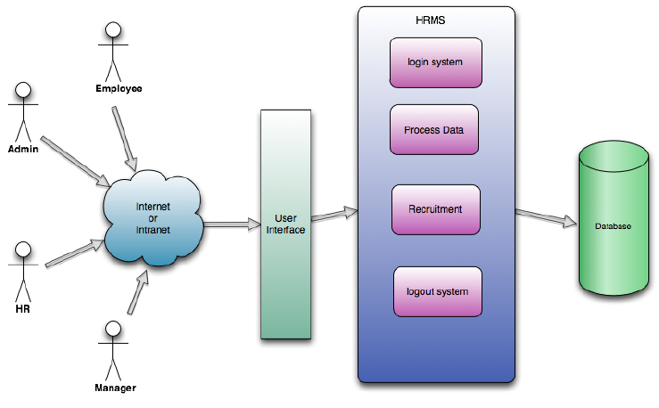

Figure 6. Common usage Use Case diagram for HRMIS

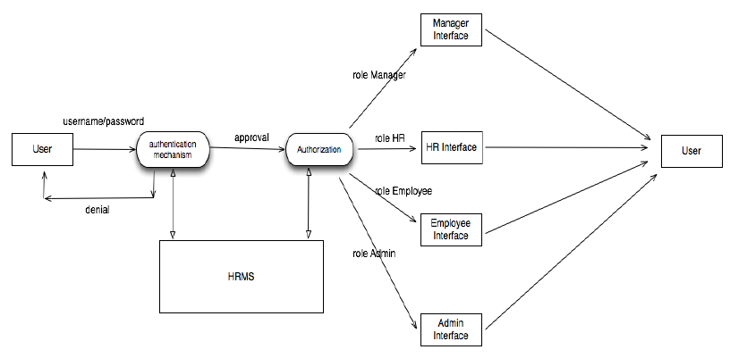
Figure 7. Authorisation/Authentication

In relation to the recruitment process, a newly recruited employee means entering or registering a new user in the system which can be done in two steps. When it is necessary to add a new user to the system, the HR must first create an employee account and in this way the HR creates/generates an ID for that user. In the second step, the admin creates a user associated with that User ID.

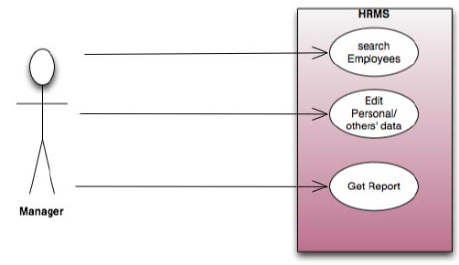
Figure 8. Manager’s Use Case diagram

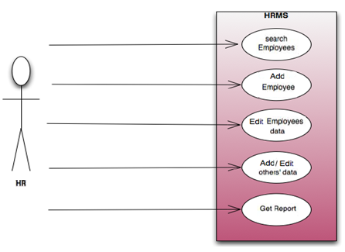
Figure 9. HR official’s Use Case diagram

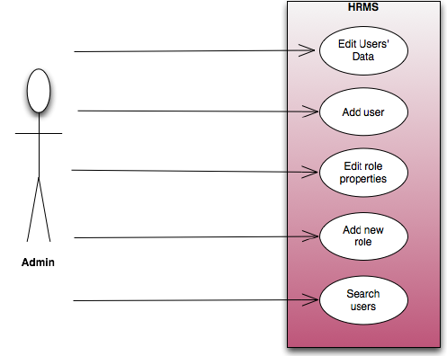
Figure 10 Administrator’s Use Case diagram

  - Description of HR software system
Each employee is added to the system by entering the personal information of an employee from HR. In the created state or status, the HRMIS assigns an ID to the newly added employee. Once added by HR, each employee has the right to enter the system through role or admin approval. In this state, the administrator defines the role of the user type and this user is given a one-time password (OTP). After the user logs in for the first time, they are prompted to change their password, which applies the institution's password complexity policy.
In the login state of the system, every user sees the same interface that requires a user with a password. After logging into the system, each user sees the same interface with different tabs related to their role type / s (manager, HR, admin, employee). At this stage:
    - Manager may:
- Search the employees who are under his/her responsibility or search all the users he/she wants, that is, a manager can search the database rows;
- Edit the data of employees who are under his responsibility;
- Obtain information report in relation to the employees s/he wants to learn about; e.g., a manager may search the data base columns;
    - Employee may:
- Edit his/her personal data (unless otherwise is specified in the internal regulations);
- View their data in an editable form (unless otherwise specified in the internal regulations);
- Upload personal photos on their profile (unless otherwise specified in the internal regulations).
    - The HR Official may:
- Search the employees who are under his/her responsibility;
- Get a report for an employee, or employees;
- Adds the employee by entering some personal data specific to that employee;
- Edit the employee data;
- Add and/or edit vacations (days off) for each employee;
- Add/update/remove supporting documents;
- Maintain/update national holidays each year.
    - Admin may:
- Edit the data of each user (administrator, HR Officer, employee);
- Add users, in other words creates a valid account for login;
- Change role properties/attributes, e.g., it may be necessary to change the attributes of each role type so that the type of tabs, each user sees, can change. This type of situation may require changing the properties of each role type;
- Add a new role to the system. Since HRMIS will be a generic and dynamic program, there can be an addition to the role types and the system will accommodate this type of need perfectly;
- Search for users who have the specified desired skills or features;
- Restore logs for each HR user activity;
- Monitor the use of software by creating various reports and statistics.

SOFTWARE FUNCTIONAL REQUIREMENTS

The software modules of the BFRAMIS system, respectively the HRMIS must include and support the following functional requirements, features and options:
- Analysing existing processes/workflow and building a new workflow that will be more effective for each employee to perform their daily tasks;
- Creating a modern program based on web technology, user-friendly and secure;
- The web application is an updated and professionally maintained platform for interaction and information sharing;
- To manage the entire financial process, starting from the receipt of the invoice to the verification of payments and its finalization;
- Budget planning and execution of the budget and payments;
- Registration and administration of income and assets or non-financial assets;
- Ensures scalability of the transactions performed;
- To be able to easily customize content and post articles on a regular basis;
- To allow access for each employee based on the rights granted by supervisors (Access Identity Management);
- To digitize HR processes (e.g., personnel information, annual leave, medical leave, maternity leave, list of salaries and per diems of personnel, advance payments, administration of personnel contracts, etc.);
- It must enable the exchange of data/information between the Budget and Finance modules with Human Resources in terms of personnel salaries and salaries based on the requirements of the KJC (defined in the applicable law);
- For both modules (BFRAMIS and HRMIS) the digitized processes must be in accordance with the applicable Laws (KJK must provide information about the laws that are applicable in the institution);
- It shall create/generate various reports - basic dynamic reports (e.g., financial statements, time periods, performances, units, etc., and is shall enable customized reports based on criteria/filter selection, etc.)
- It shall create/generate management reports including control reports used by the HR /payroll staff members, as well as reports used by others such as supervisors, reports at specific time periods, or based on request, including reports related to fiscal years, calendar years, or other time periods, according to codes, etc.);
- Enables the export of reports in various format, and at least MS Excel and PDF formats;
- Notifications/Alerts to notify responsible personnel of the status of the process (e.g., waiting to be approved, waiting to be received, and/or approved, received, etc.);
- It should contain a Dashboard with the integration of options and features for each separate module (Budget, Finance including the revenue and asset management component and the HR management module);
- It enables the possibility to add/support 2FA option for improved security;
- Audit actions/events in the system;
- Logs should not be stored on the same server as the program;
- Cluster of database servers for improving data security & data integrity & high availability;
- User session data must be coded (encrypted);
- Enables user authentication through integration with Active Directory (AD).

SPECIFIC REQUIREMENTS
- MUST support system backup and restore;
- MUST support data archiving;
- Must be installed in different instances of the database (one for the Finance and Budget, Revenue, Asset’s system and one for the HR management system);
- The application database and related components must be suitable for and fully support the KJC infrastructure (e.g., support to be hosted and virtualized on virtual platforms based on Microsoft Hyper-V technology and/or VMware latest versions). The infrastructure should be containerized either in Docker or similar platforms.
- The web application must be flexible and allow further development/extension in the future with other features or options (as required) or if the work processes shall change within the Institution;
- The system must contain the system administration module, which must define system configuration parameters, system user management, system access configuration management (the system access management module must have the possibility of defining access up to the field– category, subcategory level, etc.)
- For each control used within the system, the system must enable the possibility of defining access for the relevant group of system users. It should enable the registration and administration of the organizational structure of the institution (the existing hierarchy should be taken into account). Activity log monitoring at both the application level and the database level.
The possible Budget and Finance Software Features could be as in Figure 11, and the possible database architecture for the HR management module could be as in Figure 12:
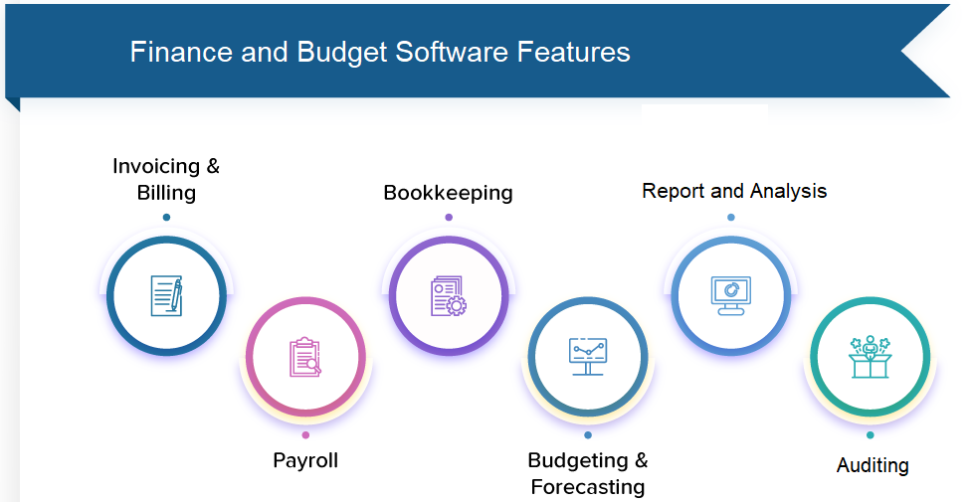

Figure 11. Possible features of the BFRAMIS software module

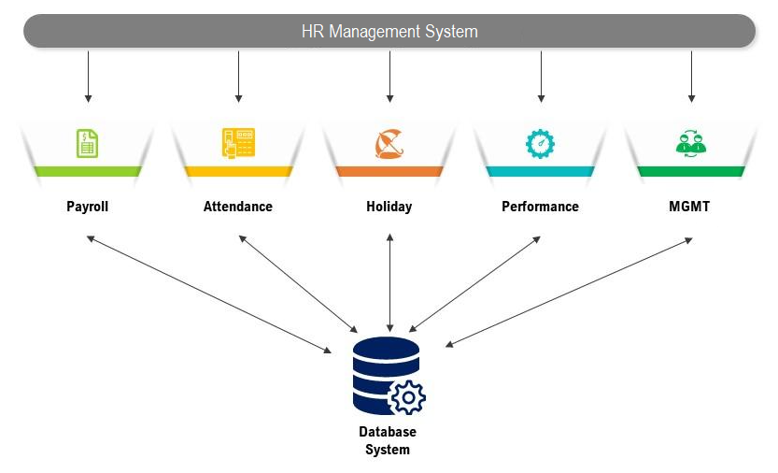
Figure 12. Possible HRMIS database architecture

CORE SERVICES

Web Application Development
- Designing a platform based on web application (web application) for desktop and mobile devices (responsive design);
- The web-application must be in the official languages (Albanian, Serbian) and English;
- Using improved and cost-effective techniques to test web application design, usability, functionality and security;
- The web application must be compatible and fully responsive with current versions of most web browsers including optimization for mobile devices;
- It shall enable adding a general search functionality with dynamic search filter;
- The web-application should offer a reporting dashboard, where various reports and statistics are generated and exported in other formats;
- The web application must be reviewed and tested for security threats and vulnerabilities;
- The web-application should include the components of the budget, finance, revenue and non-financial asset management module:
  - Budget and finance planning and execution
  - Budget and Finance Management
  - Administration of Non-Financial Assets
  - Administration of personal income/revenues
  - Basic audit
  - Reporting and Dashboard analysis

- The web-application must include the components of the HR module:
  - The directory of employees
    - Personal data of the employee
    - Department/Division/Sector or other division
    - Employment history (start of the year, promotions, etc.)
    - Personnel administration /Management of documents - contracts, salaries, etc.
    - Involvement in projects
    - Holidays
    - Administration of Official Holidays
    - Training and professional development management
    - Administration of salaries/per diems
    - Attendance
    - Management and classification of work positions
    - Recruitment and staff
    - Personnel administration
    - Employee performance
    - Discipline

Web Application Hosting
- The Software System (Web-Application BFRAMIS and HRMIS) will be hosted in the IT environment/infrastructure in the Data Centre of the KJC.
- The Software System (Web-Application) must operate within the Intranet Network (provided by the Government of Kosovo) in the KJC, and the relevant offices of the Courts throughout Kosovo at all their levels.

Maintenance & editing of the Web - Application
- Employees of institutions must be able to edit by adding and deleting the content using the dashboard (Content Management System - CMS).
- The contractor will provide instructions for using the admin/user interface of the CMS panel.
- The contractor will enable the storage of the complete backup copy of the database, in the place where the application is hosted (KJC Data Centre Infrastructure).
- The contractor must provide an automated system that will archive/ create backup of the database as defined in the Data Backup and Restoration Policy (if applicable), otherwise the backup must provide an automated system procedure on a daily/weekly and/or monthly/annual basis, as per the institution's request.

Security and Technology
- The programming language, software development framework and software tools for application software development must meet the following criteria:
- Security (compliance with OWASP according to the ASVS project);
- The possibility of development in the future (Scalability);
- Performance (fast execution performance);
- Maintenance (easy maintenance).
- The Database Management System (DBMIS) for database management and administration should be based on products provided by Microsoft. Taking into account that the KJC has a cooperation agreement with the Agency for Information Society (AIS) for the use of the framework contract between AIS and Microsoft and the professional staff, the decision was taken to use the products offered by Microsoft.

Application Audit
The system should record all actions that occur within the system, the system user who made the change, the time the change was made, and other important information as appropriate while retaining all previous states. The data that are changed, before the change is allowed must enter the history in chronological order, and newly changed data must come as a new entry in the system.
The system must enable the storage of any action, decision or document that is registered in the system or deleted from the system, by saving the date and time of registration/deletion.

PROJECT PHASES
The scope and work phases of the project include the following main work areas:
- Gather and analyse the existing work flow and create a more efficient workflow and requirements of the KJC within the scope of the project (provide report);
- Designing and creating web-applications from scratch based on the institution's needs (submit the software design and database structure to the KJC – it must be approved by the KJC before starting with the software coding);
- Providing\Delivery of the developed software application and its documentation;
- Software application testing, testing real/productive environment (live-production);
- Provision of employee/user training and user guides/manuals in official languages;
- Providing support and maintenance of the Software as defined in Section 15;
- Providing/Delivering the Source Code of the software and its versions, since the software is considered the intellectual property of the KJC.

PROJECT REQUIREMENTS
- The development team MUST consist of a multi-disciplinary team, consisting of analyst(s), user-interface designer(s), software designer(s), software developer(s), software architect, project manager and official expert in the field of budget, finance and human resources;
- The development team must have experience with the development process as well as with the development environment;
- The contractor MUST demonstrate the competencies and experiences of the team members who will be part of the development team. Team members must have experience in the relevant field (Provide CV for each team member);
- The Contractor's consulting team will be required to meet with the project management team at the KJC office to agree on roles and responsibilities (who does what);
- The contractor must recommend how will the delivery of the project be achieved, with an implementation plan in order to illustrate this – to provide timelines for milestones;
- The contractor must manage and take full responsibility for deliveries;
- The contractor must appoint a Project Manager who will be the contact point with the KJC - throughout the duration of the project;
- The contractor must appoint a designated work analyst to assist with workflow & work processes and to ensure that KJC work processes are fully understood;
- Any impact on the existing IT infrastructure should be minimal, with all planned impacts that are identified and planned;
- The requirements for KJC resources during the process should be identified early, including the potential risks of the project;
- Detailed project plans must include all resources (professional capacities) for each position;
- The administrative process that needs to be followed, which should be supported by BFRAMIS and HRMIS, should be analysed in more detail by business analysts before starting the design of the software system;
- Personnel responsible for the live-production environment must perform software installations and configurations;
- The Contractor's Business Analyst/s must be fluent in Albanian and English languages and must understand the procedures of the KJC during discussions with the personnel assigned by the KJC;
- The contractor is responsible for installing the software (and supporting the hardware configuration if required) that is necessary for the development environment and the test environment. This includes configuring tasks for web (or cloud if applicable) solutions;
- All instructions for administrator levels of the software MUST be documented in English with a reasonable level of detail.
- Graphical user interface- GUI must be available in three languages: Albanian, Serbian and English;
- The contractor will be responsible for ensuring that all those involved in the project understand and comply with KJC processes and standards, particularly with the confidentiality requirements in place, in relation to sensitive data;
- The contractor will be responsible for testing the software application before proceeding to live production;
- The contractor must propose a process model throughout the complete project cycle, applied to such projects (e.g., Waterfall, Agile, Spiral, Iterative, etc.);
- The contractor must propose a detailed timetable with links to tasks/activities.

NON-FUNCTIONAL REQUIREMENTS

Performance requirements
- The number of online users (simultaneously) of the BFRAMIS system is expected to be at least 200;
- The number of HRMIS online users (simultaneously) can be estimated around 3000;
- There is no limit to the number of users to be added to the database.

Hardware requirements
- The software application for BFRAMIS and HRMIS will collect personal data of about 3000 employees, with a likelihood of increasing number.

Data Backup and Restore
- The Software must be able to back up data periodically (e.g., daily, weekly, monthly and annually). The method will be determined according to the KJC defined policies for data backup and restoration.
- It must be possible to recover the state of the complete system from the previous business day at 18:00 (relative to the time of the incident). Time-To-Recover (TTR) should take one day at most.

TRAINING REQUIREMENTS
- Training should be provided for two different groups: Common/shared users (officials) for day-to-day tasks and Administrators/Supervisors for administrative purposes of the software application;
- Training must be provided in the official languages for common Users, while for Administrators it MAY be provided in Albanian or English (to be decided by the KJC administrative staff);
- As part of the training, the training material (User-manuals) for common Users MUST be provided in the official languages, while for Administrators the training material (Administrator's Manual) can be provided in Albanian or English (KJK administrator staff will decide and notify before starting the preparation of manuals and training material).

SUPPORT AND MAINTENANCE
Table 1. Support and maintenance requirements
Support & Maintenance
1.
- The contractor MUST provide support in relation to the use of the system in the event that 'super-users' or administrators are unable to clarify, resolve an issue or express the need for more information/knowledge about the system.
- The Contractor MUST repair all failures and non-conformities of the Software throughout the duration of the contract and 12 (twelve) months after accepting the project.
- All repair service activities provided by the Contractor must be performed in accordance with "Table 2 – Service Level Agreement – SLA" (see below).
2.
The contractor must ensure:
- Service/Project Manager - the only contact point, the person who knows and understands the KJC's IT environment.
3.
a) The system and software architecture must be regularly updated and upgraded during the Support and Maintenance period.
Table 2. Service Level Agreement - SLA
Service Level Agreement - SLA
Type of declaration | Guaranteed response time | Guaranteed repair time
Reporting a critical failure | 4 hours | 8 hours from the date when the notification was received
Reporting a serious failure | 12 hours - Next Business Day | 36 hours from the date when the notification was received
Reporting a common failure | 1 working day | 72 hours from the date when the notification was received

PROJECT TIMELINE
Table 3 presents the possible time schedule of project implementation; however, the Contractor MUST propose the schedule in its bid, in accordance with the project task listed in this table.
Support and maintenance will be provided 12 months after project acceptance.
Table 3. Project time chart
No. | Month | 1 | 2 | 3 | 4 | 5 | 6
1 | Project and Contract Management
2 | Analysing, gathering and documenting detailed project requirements
3 | Detailed work process models, supporting processes and Information Management requirements –  Design approval
4 | Back-end Development, UI Design & Front-end software
5 | Supply/Delivery of the new software application solution and any additional software (if applicable)
6 | Software testing and user training
7 | Project documentation and project acceptance

PROJECT COST REQUIREMENTS
Table 4. Cost requirements
Cost requirements
Description | Comments
A full breakdown of costs should be as follows:
a) Scope
b) Supply of a new Software solution and any additional software (if applicable)
c) The accompanying costs of software licenses (if required in addition to Microsoft Licenses that KJC is responsible for providing/granting)
d) Installation
e) Training and testing
f) Ongoing support & maintenance
g) Any other costs (if required)

RESPONSIBILITIES OF THE PARTIES
The KJC will:
- Provide all the necessary IT infrastructure for the Project: servers, storage, communication lines (internet access), licenses (hardware and software), etc.
- Make available timely to the Contractor all the information, documents and files necessary to implement the service successfully and without problems.
- Ensure that there is sufficient power supply during the service activities to avoid any delay in the time schedule to be mutually agreed upon.
- Provide the security of all data, information, files and documents.
- Provide reports, forms and other materials that are required during the development and implementation of the software application system.
- Provide explanations regarding the existing system and related services, work processes, operational procedures, etc.
The contractor will:
- Ensure that the most adequate processes, methods and equipment are defined to perform the services under this contract, at competitive costs.
- Perform services with the highest standards of professional competence, ethics and integrity.
- Be responsible for any damage to the equipment as a result of negligence during the provision of the service.
- Notify the KJC in writing within a maximum of 2 days if it is unable to comply with a contractual obligation, explaining the reasons.

LIST OF ACRONYMS/ABBREVIATIONS
AIS | Agency for Information Society
API | Application Programming Interface
ASVS | Application Security Verification Standard
BFRAMIS | Budget, Finance, Revenue and Non-Financial Assets Management Information System
CMS | Content Management System
CMIS | Case Management Information System
DBMIS | Database Management Information System
ESRM | Electronic System for Revenue Management
e-Pasuria | The electronic system for property management provided by the Ministry of Internal Affairs
GUI | Graphical User Interface
HR | Human Resources
HRMIS | Human Resources Management Information System
ID | Identity Document
INTRANET | Internal network that can be accessed by authorized internal users
IT | Information Technology
KJC | Kosovo Judicial Council
KPC | Kosovo Prosecutorial Council
MF | Ministry of Finance
MPA | Ministry of Public Administration
MPB | Ministry of Internal Affairs
OCR | Optical Character Recognition
OTP | One-Time
OWASP | Open Web Application Security Project
PC | Personal Computer
SIMFK | Sistemi Informativ për Menaxhimin e Financave të Kosovës/ Financial Management Information System in Kosovo
SKJC | Secretariat of the Kosovo Judicial Council
SLA | Service Level Agreement
ToR | Terms of Reference

